Report from Online Educa Berlin 2017, pre-conference workshop entitled: “Supporting Higher Education to Incorporate Learning Analytics”
Workshop description
Learning Analytics (LA) is currently a very active topic in education, but its implementation is beset with potential pitfalls for an organisation wishing to develop extensive use of it. Building upon international experience and local knowledge, the EC-funded SHEILA Project (Jan 2016-June 2018) is creating a policy framework for higher education institutions to enable them to design and enact an LA policy for themselves, using an innovative concept mapping approach (ROMA) combined with interviews of key stakeholders in several European countries. It is a partnership of the Universities of Edinburgh (coordinator), Tallinn, Open University NL and Carlos III Madrid, with Brussels Education Services, Erasmus Student Network and European Quality Assurance Network (ENQA).
The project was at a key stage of development and OEB 2016 offered and opportunity for us to present our interim findings for comment and advice from participants, both novice and expert, in other words a reality check for the project, and also enabling participants to take away lessons from other organisations plus a draft LA framework to support discussions in their own universities and organisations.
The workshop had 15 min presentations by each speaker, each followed by a 15 min group discussion session with feedback to enable participants reactions, suggestions, ranking of importance etc for the points made and the questions posed to them about creating learning analytics policy and implementing it. After the 4 presentations, a plenary discussion was held to enable participants to offer further input, to create an overall ranking of policy and implementation factors and to share any further experiences. The workshop concluded with a short feedback evaluation.
Fifty-one participants registered from 13 countries; 32 were from HEIs, 11 from governmental or non-governmental education organisations and 8 from commercial organisations.

B.3 Main Speaker/Organiser Biographical Information
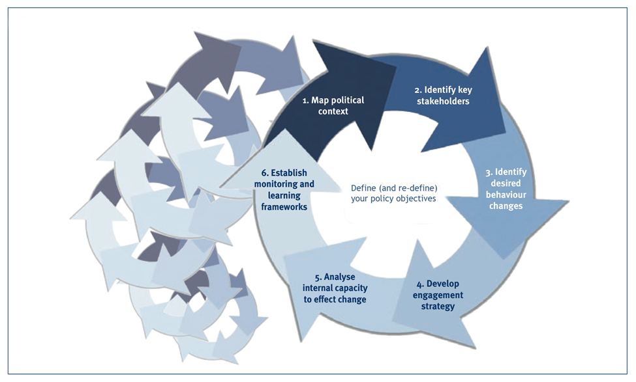
Assessment of level of interest or extent of current work in LA in your organisation:
There was consistency in the view that there was great interest generally in LA but very little of substantive work had begun. Those organisations that had made a start had established small and exploratory projects, or individual teachers had tried to use LA within their courses. The companies present viewed LA as a major area for expansion.
ROMA 1: political context mapping
As might be expected in a group from several countries and with differing roles within education-related organisations, there was diversity in the responses to this analysis step. However, some themes did emerge: competition for students/university reputation; a need for better QA/transparency/reporting; a need to reduce dropout/produce more graduates; a desire for better student learning and a move to personalisation, and coping with more students. Pressures were both external (mainly government) and internal (mainly senior admin/leaders) with little pressure from teachers or students. A major problem appeared to be legal or regulations that limited use of student personal data.
ROMA 2: key stakeholder analysis
The key stakeholders were seen by all as students, teachers, university board/leaders, government (or agencies) and, less consistently, employers. Some included IT staff specifically and some legal bodies or departments. Teacher and student unions/associations were also mentioned by some as were high schools. A few mentioned the commercial companies providing the LA solutions.
ROMA 3: behavioural changes sought
The most common changes in HEIs which should result from the deployment of LA were: reduced dropout; more engaged students; better achievement of learning outcomes; improved university reputation; more student satisfaction, and better feedback for teachers on effectiveness. For commercial organisations this would result in more sales of software/consultancy.
ROMA 4: engagement strategy
This Step was at the end of the workshop and as most HEIs or educational agencies had not yet fully engaged with LA it was a difficult ask for them. The main proposals were: develop an ethical and legal framework; develop the technical capability and capacity; ensure a sound pedagogical basis for use of LA, and set in place appropriate governance on collection, storage, access and use of student and teacher data.

Professor Jeff Haywood, co-PI SHEILA project

